Sprint 2 Meeting Evidence
Project: Campus Food Ordering Platform
Sprint: Sprint 2
Evidence Type: Meeting screenshots and Scrum communication evidence
Meeting Screenshots Included
1. Sprint 2 Planning Meeting
Date: 15 April 2026
Duration: Approximately 27 minutes
Purpose: Sprint 2 backlog selection, task allocation, workflow agreements, and improved task ownership.
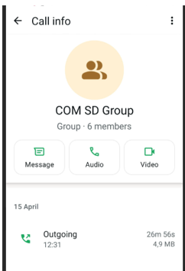
2. Sprint 2 Daily Scrum Meeting
Date: 17 April 2026
Duration: Approximately 16 minutes
Purpose: Progress updates, alignment check, GitHub branch reminders, and pull request workflow.
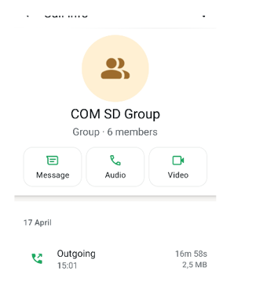
3. Sprint 2 Daily Scrum / Final Progress Meeting
Date: 19 April 2026
Duration: Approximately 29 minutes
Purpose: End-to-end system progress review, final fixes, notifications, and timestamp display discussion.
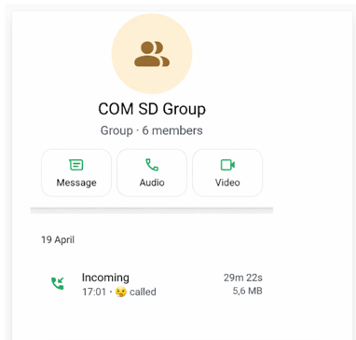

4. Sprint 2 Retrospective Meeting
Date: 20 April 2026
Duration: 10 minutes
Purpose: Sprint 2 reflection, what went well, what could improve, blockers, and next sprint action items.
